Overview
While OpenCities doesn’t currently offer a full integration with ESRI/ArcGIS, there are proven best practices to make the two platforms work together. This guide will walk through considerations for common ESRI use cases within OpenCities. We’ll also offer tips and tricks sourced from our staff and other customers to provide a consistent experience for users given the need for two GIS tools within your website.

OC Maps vs. ESRI/ArcGIS
When using both OC Maps and ESRI/ArcGIS within a single site, it can be challenging to decide which system to use over another. We’ve included some recommendations for when to use each of them below.

OC Maps  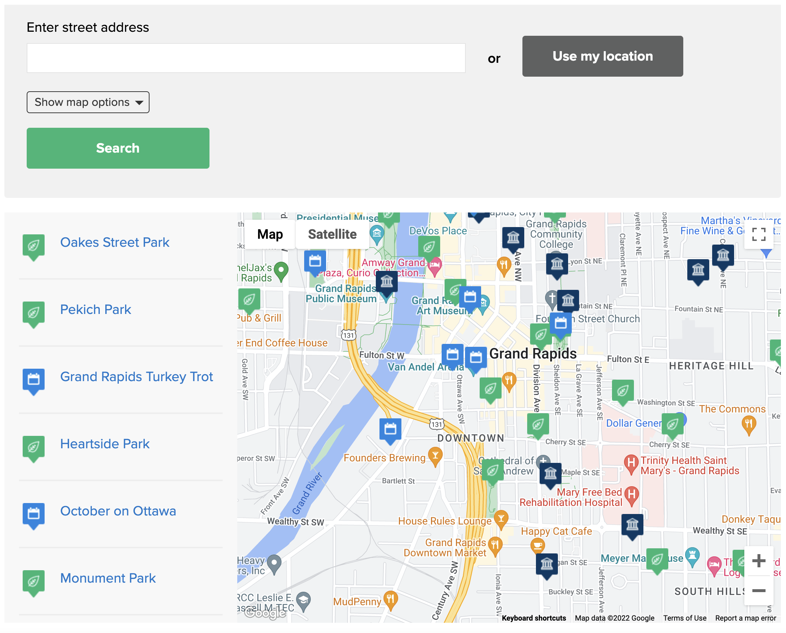 | ESRI/ArcGIS  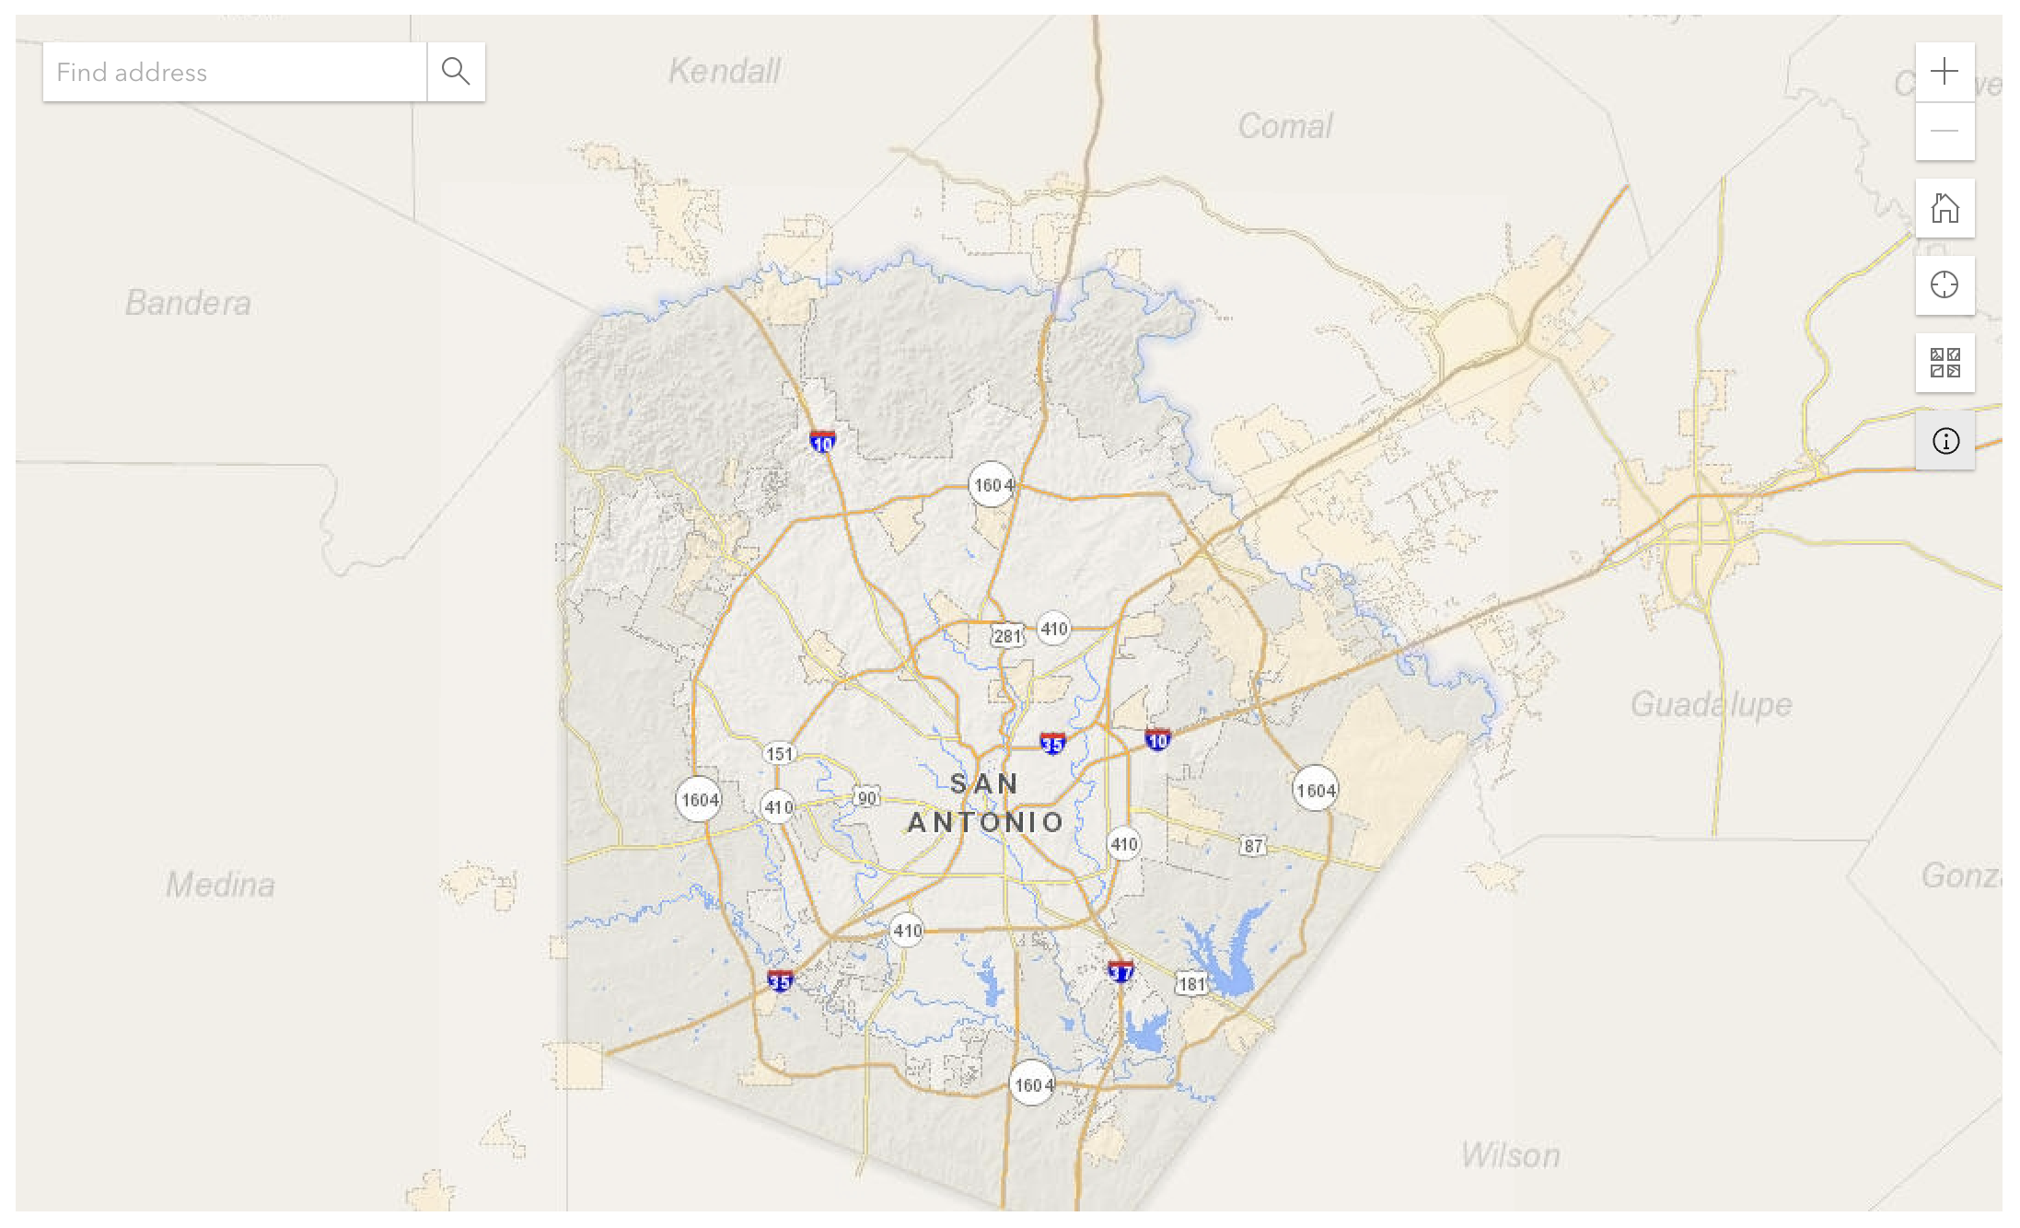
Powered by | Powered by
Google Maps | ESRI/ArcGIS
Best Practice | Best Practice
Use for simple lookups and maps based on OC content type data | Use for more complex data, boundary maps, and instances where location accuracy is essential
Coordinate System | Coordinate System
WGS84 (EPSG: 4326) | Varies, often State Planes NAD83 (EPSG: Varies)
Maps Based on | Maps Based on
Geocoded content types or KML/KMZ files | Data in your organization’s spatial database
Paid Components | Paid Components
Use of Google APIs beyond free limits | Certain operations that use ESRI/ArcGIS web services beyond those you own may consume credits

OpenCities Maps
OpenCities Maps are powered by the Google Maps API. Use of these maps is so widespread across the internet that the vast majority of users have some experience with them. On the other hand, they offer fewer features than more powerful GIS platforms, like ESRI/ArcGIS. For this reason, OC Maps are a good choice in scenarios when users need to get a quick piece of location-based information without ultra-precise location coordinates.

My Area
This tool allows users to get some basic information about what’s near them. Whether they’re looking for a nearby park, library, or school – or if they’re looking for their next trash and recycling pickup date, their school district, or their zip code – they can find it using My Area.

Because this is commonly sought information, a strong user interface is necessary. Users will want this information quickly and presented in a predictable way. This makes OC Maps the best choice for the property lookup info that My Area offers.

While certain components of My Area are more difficult to implement, we offer a series of help center articles to guide you through the process.

Certain Content Types
Some OpenCities content types offer built-in geocoding, which automatically adds latitude, longitude coordinates based on the address editors add to the page. This allows you to create map layers based on pages that exist in your site. Some content types even use templates that generate maps automatically, for example OC Event, OC Project, and others.

Maps You Create
Beyond these built-in maps, you can create your own maps within OpenCities to use as needed in your pages. Again, it’s best to keep these maps focused and geared toward use cases where your customers want some quick info and coordinate accuracy is less important.

ESRI/ArcGIS
ESRI/ArcGIS maps are powered by their own proprietary software. This system is most common among government organizations, and it offers an suite of GIS visualization and analysis tools. This tool is best reserved for web maps in a few scenarios: maps with dynamic data that update frequently and need to stay accurately synced with your spatial database, maps that display a significant amount of data, maps that show boundary or polygon layers, and other maps that require functionality beyond what OC maps support.

Maps with Dynamic Data
For maps where there is a compelling need to ensure data accuracy – and where the data is updated frequently – ESRI/ArcGIS is the best choice. These maps will be connected directly to your source spatial database, which will guarantee that the map updates when the data changes. If there is a need to show these layers in an OC map, you can use a KML/KMZ layer.

Boundary Maps
Maps showing boundaries or shapes are best suited for ESRI/ArcGIS. OpenCities doesn’t currently support creating polygon maps within the system. It’s still possible to show polygon layers on an OC map using KML/KMZ layers, but those must be generated using an external system like ESRI/ArcGIS

Complex Maps
Maps that display a significant amount of data are better-suited for ESRI/ArcGIS than OpenCities. When deciding whether to put a complex map on your site, make sure to consider whether the map will work for its target audience. In many cases, these maps are best used for specific technical audiences, like property developers or others who are interested in more granular info than a typical web user.

Maps with Customized Flyouts
OC maps are standardized to show the same info in every flyout when a user clicks a plotted point. You may need to control what shows in this flyout for certain maps, and using ESRI/ArcGIS allows you to do so. Another option is to build the layers for these maps in ESRI/ArcGIS, then use a KML/KMZ layer to display them on an OC map.

Other Maps
This isn’t an exhaustive list of the types of maps that are best-suited for ESRI/ArcGIS. There will likely be other scenarios where this tool is a better choice than OpenCities. The information detailed in this guide is intended to help you think about which tool is better for any given scenario.

Coordinate Systems
Digital maps rely on coordinate systems that convert the globe from a three-dimensional sphere to a two-dimensional grid in order to plot points or objects on them. There are a lot of different ways to do this, so there are a variety of coordinate systems available.

OpenCities maps use the same coordinate system as Google, WGS84 (EPSG: 4326), while ESRI/ArcGIS offers an exhaustive list of coordinate systems. Most municipal governments use a zone of the NAD83 because this system tends to be more accurate for smaller geographical units.

Conversion
If you plan to use geographic data from your ESRI/ArcGIS database in OpenCities maps, you’ll need to convert the data to use the WGS84 (EPSG: 4326) coordinate system. You’ll need to do this in order to use the My Area waste services functionality or if you want to show KML/KMZ layers from your GIS system on an OC map.

For iframes or simple links to maps hosted on your servers, there is no need to convert the coordinate system to WGS84.

ESRI/ArcGIS Integration

Style Guide
The most important way to ensure consistency across your two maps platforms is to define a style guide for your ESRI maps that will appear on the website. This is a challenging undertaking within governments, largely because GIS staff are often distributed throughout the organization in multiple departments. Still, the effort is worthwhile because maintaining a similar look and functionality in your maps across the two platforms makes for a more consistent user experience.

Style Guide Recommendations
- Set a standard base map and consider an option that aligns closely with the Google Maps default base layer that OC maps use
- Define color palettes for both quantitative and qualitative data displayed on maps
- Offer expanded color options beyond your branding style guide, as maps often show complex data that calls for additional distinct colors
- Include either exact icon files or standards for icon development when a map calls for differentiation beyond simple color variations
- Require the search bar to appear in the upper left corner of the map on desktop and across the full width of the top on smaller devices
- Standardize the color of map flyouts/pop-ups that show more information
- Set limits on the number of data points shown within a single flyout/pop-up
- Host the style guide as html content either within your public site or on your intranet so that your GIS staff can readily access it using a bookmarked hyperlink

Iframes
This is the simplest way to show your ESRI/ArcGIS web maps within an OC website. Iframes allow you to show content from a third-party site directly within a page on your website. Because ESRI/ArcGIS is such a robust tool – often providing multiple ways to accomplish the same task – there are some things to consider when implementing your iframes.

Source URL
There are typically multiple URLs for each of your online maps created in ESRI/ArcGIS, and your ability to customize the functionality of your iframes depends on which of those you set as the source. We recommend using the Embed Map URL so that you can use several query parameters to adjust the usability of your maps.

Using the Embed Map URL offers greater control over your iframe maps, allowing you to add query parameters to disable zoom on scroll, change the base map, add layers dynamically, and more. Using this URL gives you significantly greater control over the user experience of your ESRI/ArcGIS iframes. With these parameters, you’ll be able to match your iframes’ functionality more closely with that of the Google-powered OC maps.

CSS Classes
We can create CSS classes to improve your iframes, making them more responsive. The example below shows how this works for a specific map aspect ratio (the height of the map divided by the width of the map). You also have the ability to vary the aspect ratio of your maps using these classes based on the device size using CSS media queries. This is helpful because a wider aspect ratio is often more user-friendly for desktop users, while a taller aspect ratio favors mobile users. We can meet both needs using this approach.

Example CSS and HTML

CSS
// iframe container class
.resp-16-9 {
position: relative;
overflow: hidden;
padding-top: 56.25%;
}

// iframe class
.resp-iframe {
position: absolute;
top: 0;
left: 0;
width: 100%;
height: 100%;
border: 0;
}

HTML
<div class=”resp-16-9”>
<iframe class="resp-element" src="https://www.arcgis.com/apps/Embed/index.html?webmap=3ec4c6d1353b4832b2db4f7f76579ecb&extent=-85.7079,42.9429,-85.6238,42.9944&zoom=true&amp;previewImage=false&amp;scale=false&amp;search=true&amp;searchextent=false&amp;disable_scroll=true&amp;theme=dark&amp;scale=false&amp;search=true&amp;searchextent=false&amp;disable_scroll=true&amp;theme=dark&amp;disable_scroll=true"></iframe>
</div>

KML/KMZ Layers
OC Maps can show layers based on .kml (or .kmz) files. Because ESRI/ArcGIS supports this file type, it’s possible to show data from your GIS system on the same map as layers generated based on OC content types. There are a few things to consider when deciding whether to bring map layers using KML/KMZ into OC maps rather than an iframe.

Files or URLs
OpenCities can support either a file upload or a link to your hosted KML/KMZ files. In ESRI/ArcGIS you can either export the file or setup a KML rest service. Keep in mind that using the KML rest file will ensure that your map stays up to date when there are changes in ESRI/ArcGIS, while using a file export will not.

Styling and Flyouts
The styling and flyouts of layers generated from KML/KMZ are dictated by the markup within the file. This should reflect how your map layers look within ESRI/ArcGIS before export, so make sure things look right in the source system before bringing them into OpenCities. The info that shows in the flyout will exist within a <description> tag in the KML/KMZ file.

Example KML/KMZ Style Markup
<Style>
<IconStyle>
<scale>1.2</scale>
<Icon>
<href>https://earth.google.com/earth/rpc/cc/icon?color=d32f2f&amp;id=2000&amp;scale=4</href>
</Icon>
<hotSpot x="64" y="128" xunits="pixels" yunits="insetPixels"/>
</IconStyle>
<LabelStyle>
</LabelStyle>
<LineStyle>
<color>ff2dc0fb</color>
<width>4.8</width>
</LineStyle>
<PolyStyle>
<color>40ffffff</color>
</PolyStyle>
<BalloonStyle>
</BalloonStyle>
</Style>

Sample KML/KMZ Flyout Markup
<Placemark id="08E30EB5491A5421363B">
<name>Fire Station 1 – Glebe Road</name>
<description><![CDATA[<div>500 S Glebe Rd<br></div><div>Arlington, VA 22204<br></div>]]></description>
<gx:mid>/g/1tl1jslt</gx:mid>
<gx:fid>0x89b7b6a4073471c7:0x86fbeca3cdcba41f</gx:fid>
<LookAt>
<longitude>-77.09597119999999</longitude>
<latitude>38.86671450000001</latitude>
<altitude>0</altitude>
<heading>0</heading>
<tilt>0</tilt>
<gx:fovy>35</gx:fovy>
<range>800.7984626372227</range>
<altitudeMode>relativeToGround</altitudeMode>
</LookAt>
<styleUrl>#__managed_style_0F7EDFB9B81A545786CA</styleUrl>
<gx:Carousel>
</gx:Carousel>
<Point>
<altitudeMode>relativeToGround</altitudeMode>
<coordinates>-77.09597119999999,38.86671450000001,0</coordinates>
</Point>
</Placemark>

Advanced ESRI/ArcGIS Integration Options
These options for integrating with ESRI/ArcGIS offer expanded options and functionality, but they are considerably more time-intensive and experimental. While our customers are frequently using the integration options discussed in the last section, these options are mostly uncharted territory. You will want to weigh the user benefits with the development effort before going down one or more of these paths.

JavaScript Iframe Improvements
You can consider adding additional functionality to your ESRI/ArcGIS iframes based on established best practices for web maps. The one that immediately comes to mind is holding the ctrl key and scrolling in order to enable zoom on the maps. This could be useful since Google maps use this feature, and adding it to ESRI/ArcGIS iframes would make for a consistent experience.

ESRI/ArcGIS JavaScript Package
There is a JavaScript API that allows for developing ESRI/ArcGIS maps within your website. There has been some limited use of this API to generate maps among OpenCities customers, but it is not widely used. Before taking this approach, you should consider what benefits this offers over the more simple iframe option.

